WORKSHEET – AMAZING ANIMALS 2

1/ Poslech učebnice. Poslechněte si nahrávku a spojte k větám zvíře o kterém se mluví.

- It eats leaves. 1. penguin
- It eats meat. 2. gorilla
- It eats insects. 3. lion
- It eats fish. 4. crocodile
- It eats meat and fish. 5. frog

2/ Přiřaď k zvířatům věty. Přepiš věty Pod obrázky.
It doesn`t eat meat. It eats insects. It lives in a hot place.
It doesn`t live in a hot place. It swims. It flies.
It doesn`t fly. It eats meat. It eats leaves.
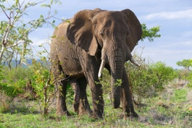
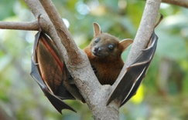
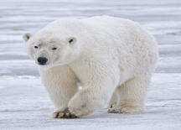
Tato fotka od autora Neznámý autor s licencí CC BY-SA

3) Přečti si text a doplň, o které zvíře se jedná.

It eats meat and fish. It doesn`t live in a hot place. It swims. ...........................
It doesn`t eat meat. It flies. It`s a ...........................
It eats insects. It doesn`t fly. It swims. It`s a ...........................

